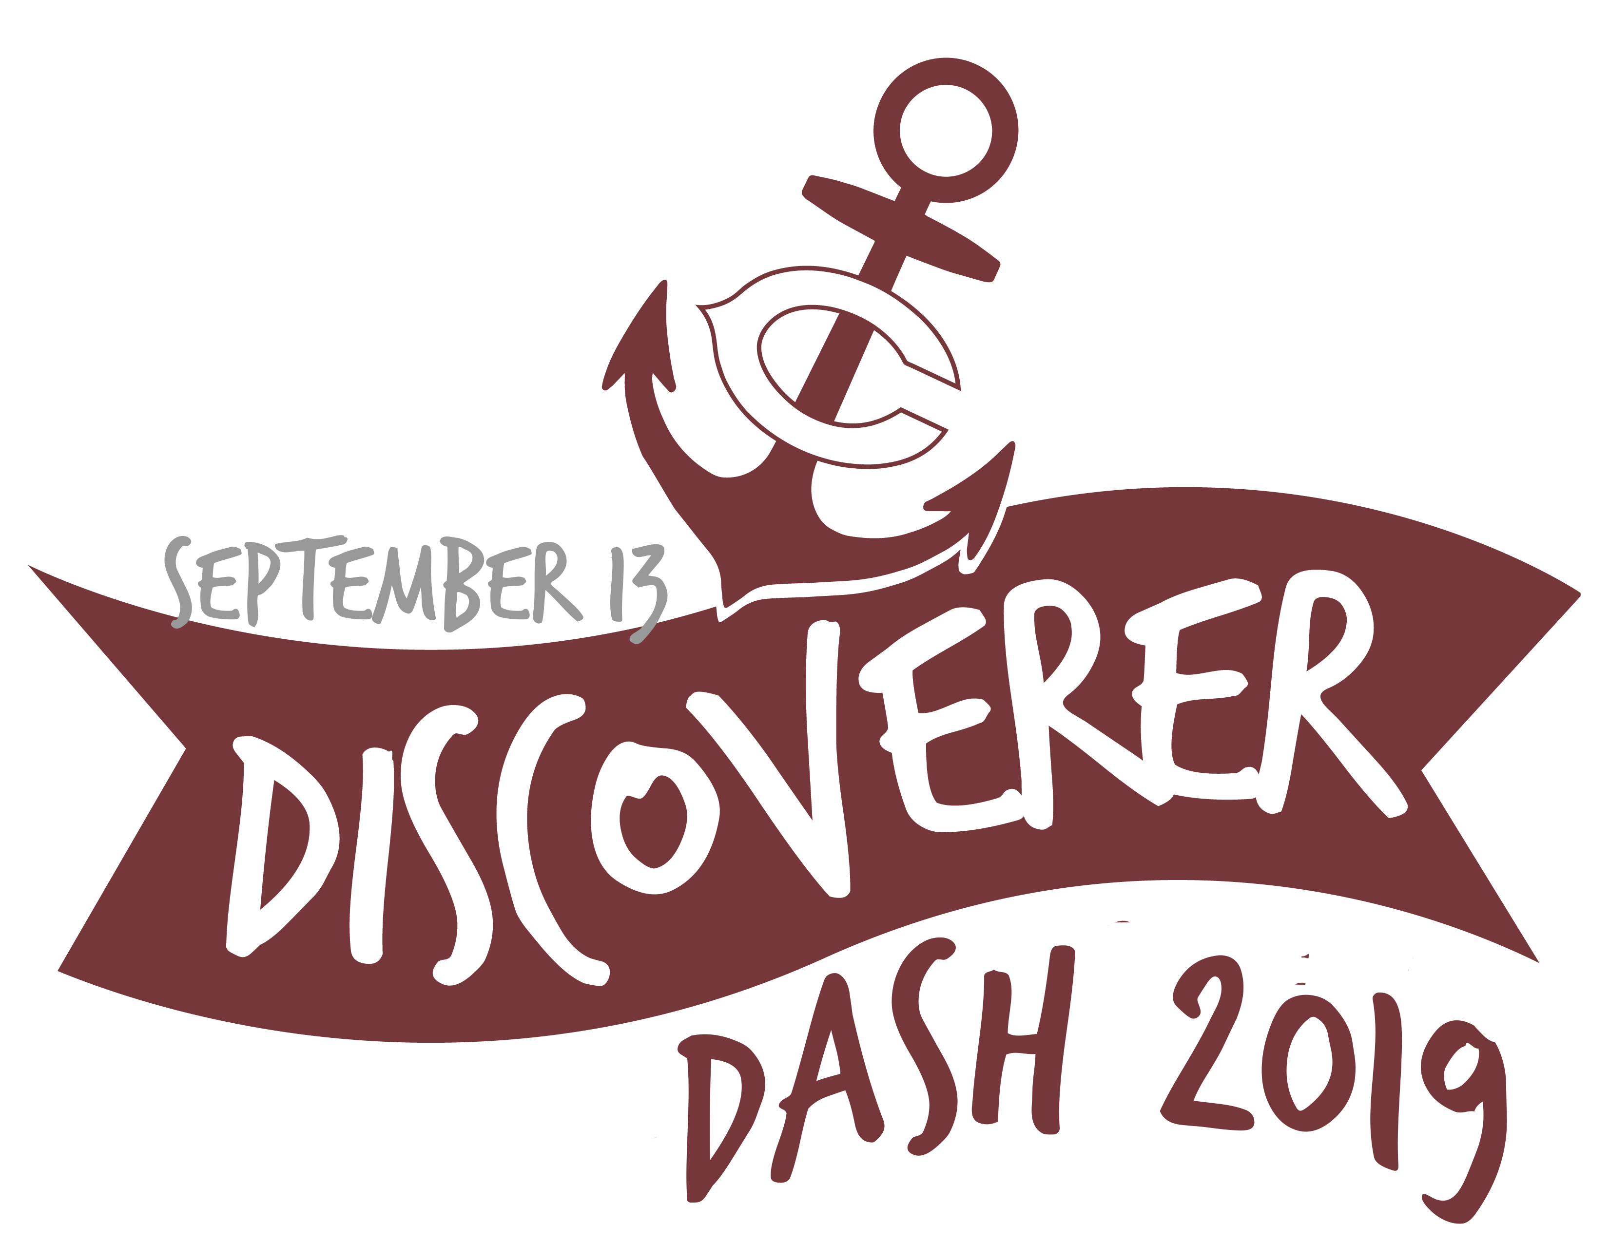
Discoverer Dash 2019
Please type or print legibly
Name: ________________________________________________ Age: ___________ Grade: ____________ Shirt Size: __________

Address: _________________________________________ City: _____________________ State: _____ Zip Code: ________________

Parent Name: _________________________________________ Cell Phone Number: ______________________________________

Email: ______________________________________________________

Age Category:

Future Discoverer (ages 3-5)
Discoverers in Training (ages 6-8)
Discoverer Prospects (ages 9-11)
Discoverers (ages 12-14)

The Discoverer Dash will be Friday, September 13th at Memorial Stadium, Pawnee Park at 5:30 p.m. Children must be lined up and ready to go on the north side of the stadium by 5:15 p.m. The Discoverer Dash will take place prior to the Columbus vs. Elkhorn football game. Registration is $10 and includes a T-shirt. Parents may run with the Future Discoverers. T-shirts will be given out before the race.

Waiver (MUST BE SIGNED)

In consideration of your accepting this entry, I, the below signed, intending to be legally bound, for myself, my heirs, my executors and administrators, waive and release and any all rights and claims for damages I may have against the race, and sponsors and their representatives, successors and assigns for any and all injuries suffered by me in said event. I attest that I will participate in this event as a footrace, that I am physically fit and sufficiently trained for the completion of this event. Furthermore, I hereby grant full permission to use my name and likeliness, as well as any photographs and any record of this event in which I may appear for any legitimate purpose, including advertising and promotion.

Parent or Guardian Signature: _____________________________________________________________________________________

No Refunds will be issued for any reason.

Make checks payable to the Columbus Public Schools Foundation

Please send signed form and registration fee to:
Columbus Public Schools Foundation
P.O. Box 947
Columbus, NE 68602-0947

